Lingdale Primary School
Year Five & Six Curriculum Overview 2021-2022

Year 5  Year 6 | Autumn Term |  |  |  | Spring Term |  |  |  | Summer Term
 | Autumn 1  8 weeks |  | Autumn 2  7 weeks |  | Spring 1  6 weeks |  | Spring 2  6 weeks |  | Summer 1  5 weeks |  |  | Summer 2  7 weeks
Topic | WW1- The bombing of Whitby  Sinking of the Rohilla  Who were the real heroes? Victorian Childhood |  |  |  | Are villains always bad? Are dogs a man’s best friend?  Local History – to extend pupils’ chronological knowledge – changes in crime and punishment from the Anglo- Saxons to present day |  |  |  | A study of aspects of Brazil and Japan- driven by the novel Kensuke’s Kingdom.
Enrichment- how to close the knowledge gap of disadvantaged children | Visit to Whitby –locate key areas –locate on map. Lifeboat station-if Covid restrictions are lifted  Year 5/6 3 day residential to Carlton – teambuilding experience  Visit to Middlesbrough Little Theatre- A Christmas Carol performance Nov 25th |  |  |  | Visit from Maxi’s Mates- or similar provider to learn about the strays |  |  |  | Use of ordnance survey maps to explore local area  Danby Moors Centre
Reading | Children will explore topic specific texts throughout the year and explore a range of genres. They will develop and improve skills across all reading content domains: retrieving information from fiction and non-fiction; making inferences and deductions from the text – supporting their answers with evidence. They will make predictions, explaining the meaning of words in context and the impact upon the reader as well as summarising the key events from more than one paragraph and making comparisons within a text. These skills will also be transferred when considering their own writing.  Children will have guided reading sessions four times per week for 25 minutes using the reciprocal reading approach and inference training when working with an adult before answering comprehension questions linked to the reading domains. They will also engage in termly reading weeks where they can apply their reading skills to specific topic related texts. In KS2, the children’s comprehension questions will take the forms similar to those they will experience in termly assessments and SATS to ensure they are confident with the structure of the questions.  Children will get the opportunity to read with an adult regularly- those needing the most support will be heard read at least 3 times a week.
Key Texts | Evie’s War- Holly Webb –class novel  The story of WW1 for children- John Malam GR  A Christmas Carol- Charles Dickens-class novel-playscript for majority- original classic for GT reading sessions run by SN |  |  |  | The Highwayman-Alfred Noyes  A Dog’s Purpose-W.Bruce Cameron |  |  |  |  | Kensuke’s Kingdom- Michael Morpurgo  The Story of Sadako
Spelling and Phonics | Children will be given a spelling list weekly with the opportunity to practise daily through a range of spelling activities. This will be a mixture of words from a spelling pattern and the statutory spelling list from the curriculum. Those children who need additional support will also, where appropriate, have multi-sensory phonics sessions or Read Write Inc. depending on their needs. Children will have a spelling test every Friday and be given their new spellings the same day. In upper KS2 children will be required to identify the word class the spellings belong to.
Grammar and Punctuation | Children will begin each English session with a grammar and punctuation focus for 15 minutes of the lesson specifically linked to their writing. They will also have a specific lesson once a week to develop new skills that will be reinforced throughout the year. This will include a ‘Word of the Week’ to help develop the children’s vocabulary further and will be genre specific to support their writing.
Writing Opportunities  Autumn 1- reading based | Composition  Narrative –  Consider how authors have developed characters and settings in what they have read. Describe character of Mr Maitland and atmosphere he creates in the household.  War poetry – to recite in lessons  Recount- of trip to Carlton/ Whitby-  Reviews- after reading Evie’s War and visiting the theatre  Instructions –based around Victorian cooking – Afternoon tea.  Play scripts- conventions of |  |  | Recount –after visiting the dog centre  Poetry – Narrative  Diary Writing – from Ned/Bess’ perspective  Persuasive Letter – Letter to persuade dog to be adopted |  |  |  | Newspaper Report – About Hiroshima  Letter from Sadako in hospital  Discussion Text – Should Kensuke stay on the island or return to the mainland?
Maths | Place Value  Properties of shape (angles)  Addition and Subtraction  Multiplication and Division  Place value including negative numbers  Addition & Subtraction  Multiplication & Division  Roman Numeral revision | Fractions and decimals  Measure – length and perimeter  Statistics – bar charts  Place value  Multiplication and division  Time  Measure – length, perimeter and area  Conversions  Place value  2D3D shapes  Angles  Multiplication and division |  | Addition and subtraction  Measure – length  Properties of shape (3D and 2D)  Multiplication and division |  | Fractions, decimals and percentages  Place Value  Statistics – line graphs  Position and direction  Measure – capacity and mass  Angles  Multiplication and division |  | Addition and subtraction  Fractions and decimals  Time  Multiplication and division  Angles  Fractions and decimals  Algebra  Interpret and present discrete and continuous data  Addition and subtraction  Multiplication and division  Place value |  |  | Statistics – timetables  Properties of shape  Percentages  Multiplication and division  Place Value  Measure  Place value  Addition and subtraction  Multiplication and division  Co-ordinates  Angles  Area and Perimeter  Ratio and proportion
Science  As our classes are split into two year groups per class, we use a two year rolling programme so children experience all of the curriculum objectives across a two year period. | Light  Recognise that light appears to travel in straight lines.  Use the idea that light travels in straight lines to explain how objects are seen.  Explain we see things because light travels from light sources to our eyes or via an object into our eyes.  Explain why shadows have the same shape as the object that cast them. | Electricity  Associate the brightness of a lamp or the volume of a buzzer with the number and voltage of cells used in the circuit  Compare and give reasons for variations in how components function, including the brightness of bulbs, the loudness of buzzers and the on/off position of switches  Use recognised symbols when representing a simple circuit in a diagram |  | Living things and their habitats  Describe how living things are classified into broad groups according to common observable characteristics and based on similarities and differences, including micro-organisms, plants and animals.  Give reasons for classifying plants and animals based on specific characteristics.  Recognise that living things have changed over time and that fossils provide information about living things that inhabited the Earth millions of years ago |  | Animals including humans  Identify and name the main parts of the human circulatory system, describe the function of the heart, blood vessels and blood.  Recognise the impact of diet, exercise, drugs and lifestyle on the way their bodies function.  Describe the ways in which nutrients and water are transported within animals, including humans |  | Evolution and Inheritance  Recognise that living things have changed over time and that fossils provide information about living things that inhabited the Earth millions of years ago  Recognise that living things produce offspring of the same kind, but normally offspring vary and are not identical to their parents |  |  | Evolution and Inheritance  Identify how animals and plants are adapted to suit their environment in different ways and that adaptation may lead to evolution
Art | Use sketch books to record observations  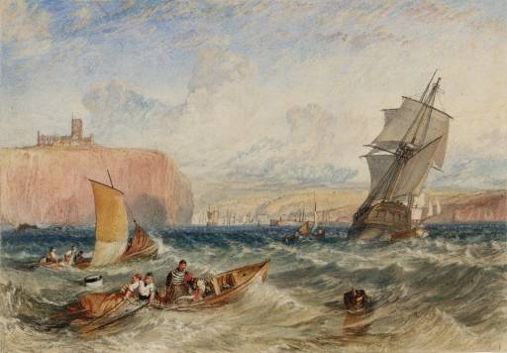  Improve art & design techniques  Artist Focus – Joseph Turner  https://www.tate.org.uk/kids/explore/who-is/who-jmw-turner  Take sketch books to Whitby  Gustav Klimt 1862-1918  The Kiss  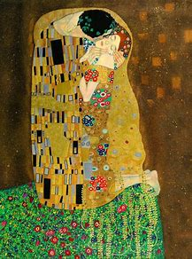 |  |  | Use sketch books to record observations  Improve art and design techniques  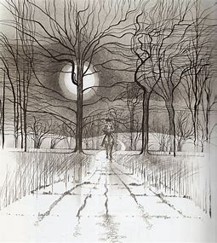  Artist focus – Charles Keeping  The Highwayman |  |  |  | Use sketch books to record observations  Improve art and design techniques  - Sculpting Art Deco  Architect focus – Paul Landowski  Biography of his achievements  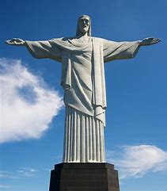  Make their own sculpture- relate to the Knife Angel- Alfie Bradley  Look at scale/ratio between the two different sculptures. Angel of the North  Origami linked to story of Sadako
Computing  JF to run a coding club after school on Thursday p.m. | Computer Science  Understand computer networks  How information is shared and the opportunities for communication  Decompose programs into smaller parts  Use selection in programs  Use search technologies  Use logical reasoning to explain how simple algorithms work  Information Technology  Select use and combine a variety of software to create content  Collecting and presenting information (Word and Powerpoint) |  |  | Computer Science  Use search technologies effectively, appreciate how results are ranked and be discerning about evaluating digital content  Design, write and debug programs  Use  Information Technology  Select use and combine a variety of software to create systems  Evaluating data (databases)  Digital Literacy  Use technology safely, respectfully and responsibly  Recognise acceptable/unacceptable behaviour, identify ways to report concerns |  |  |  | Computer Science  Use search technologies effectively  Use sequence, selection and repetition in programs  Work with variables and various forms of input and output  Design, write and debug programs that accomplish specific goals  Information Technology  Select use and combine a variety of software to create programs  Collecting and analysing data (spreadsheets)
D.T. Design  Make  Evaluate  Focus: | Food technology Cooking and nutrition  Understand and apply the principles of a healthy diet  Prepare and cook a variety of predominantly savoury dishes using a range of cooking techniques  Understand seasonality, and know where and how a variety of ingredients are grown, reared, caught and processed  Compare the difference in diets between the wealthy and poor Victorians. Victorians were the first to invent afternoon tea- children to create their own menu for afternoon tea.  Invite parents if Covid restrictions ease |  |  |  |  |  |  | Design- A boat/yacht that can float  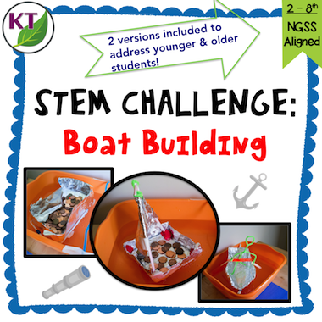
Geography | Location knowledge  Name and locate countries and cities of UK, geographical regions and their identifying human and physical characteristics, key topographical features ( including hills, mountains, coasts and rivers) and land use patterns; and understand how some of these aspects have changed over time  Place knowledge  Understand geographical similarities and differences through the study of human and physical geography of a region of the UK  Visit to Whitby |  |  |  |  |  |  | Location knowledge  Locate the world’s countries using maps to focus on Europe and North and South America, concentrating on their environmental regions, key physical and human characteristics, countries and major cities- Rio de Janeiro  Use field work to observe, measure, record and present the human and physical features of the local area  Geographical skills and fieldwork  Use maps, atlases, globes and digital/computer mapping to locate counties and describe features studied-
History | Autumn 1  Local history study  A study of a site dating from a period beyond 1066 that is significant in the locality- Whitby  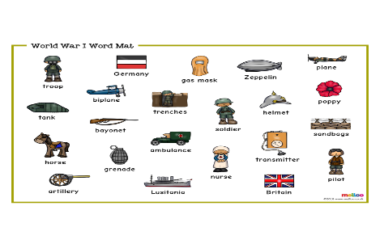  WW1- Origins of. How the local area was affected.  Victorian childhoods and significant people such as Dr Barnardo.  Autumn 2  http://primaryhomeworkhelp.co.uk/victorians/timeline.htm  The changing power of the Monarchs- Victoria |  |  | A study of an aspect or theme in British History that extends pupils’ chronological knowledge beyond 1066  Local History – to extend pupils’ chronological knowledge – changes in crime and punishment from the Anglo- Saxons to present day  Are all Villains bad?  Devise historically valid questions about change.  Understand how our past is constructed from a range of sources and that different versions of past events may exisit. |  |  |  | Hiroshima  Timeline of the key technological advances that Kensuke has missed
French | Revision of phonics  Understand and respond to a range of classroom instructions  Ask and respond to questions about likes/dislikes, time, feelings  Read and show understanding of words and phrases  Appreciate stories, songs poems and rhymes  Use a dictionary to find meanings and spellings of French words  Positioning of adjectives in sentences |  |  | Anticipate with some accuracy the spelling of new words using their knowledge of phonics  Ask and respond to questions  Express opinions and respond to others  Ask for help in French  Describe people places and things  Appreciate stories, songs poems and rhymes  Read with some level of accuracy in pronunciation  Understand the codes in dictionaries and how to use this knowledge in writing  Describe actions in writing |  |  |  | Recognise place and agreement of adjectives  Conjugation of key verbs  Prepositions, connectives and qualifiers  Adapt phrases to create new sentences  Write sentences about a range of everyday activities  Read aloud with accurate pronunciation  Read short texts and answer questions
Music | Children will be learning for?? weeks throughout the year and will learn how to perform using the instrument with increasing accuracy, fluency and control. In addition, they will understand musical notation through this work. They will also learn the?? for ?? weeks in the Spring term.  Children will also listen to a range of live and recorded music at the start of the day as they enter the classroom from different traditions and from great composers and musicians. Half termly focus in Monday’s assemblies starting with classical music-
SMSC  Using SCARF website- led by L.S | New beginnings- School Council/new Head boy/Girl  Loss and Bereavement  Target setting  Sanctions and rewards  ‘Going Yellow’ – children’s mental health  Class assembly | Christmas performance  Good to be me  Say no to bullying |  | E safety  Review of targets  Going for goals |  | Accepting other cultures  Getting on and falling out |  | Relationships  British Values 1. Democracy – voting – would you stay or leave the island? 1. Conscience corridor  2. The Rule of Law – What happens if someone goes missing at sea? 3. Mutual Respect – looking after one another and the environment 4. Individual Liberty – Kensuke’s choice to stay on the island 5. Tolerance – Kensuke feelings towards Michael wanting to leave |  |  | Changes- Transition
 | Children will have a weekly PHSE session with Mrs Stephenson dealing with elements of SMSC and school will have an assembly on a Monday morning and an achievement assembly on a Friday afternoon. Moreover, there will be a hymn practice assembly on a Thursday afternoon. All year 5 /6 pupils will be attending a three day team building residential at Carlton in September. Children will be offered a variety of afterschool clubs as well as booster sessions to close the Covid Gap.
RE | - Beliefs and questions  - The journey of life and death  - Teachings and authority  - Inspirational people  - Worship, pilgrimage and sacred places  - Symbols and religious expression  - The journey of life and death  - Religion and the individual  - Religion, family and community  - Beliefs in action in the world  Why is Muhammad (PBUH) important to Muslims?  Why is the birth of Jesus important to Christians?  Why is the Buddha important for Buddhists?  How do Buddhist beliefs affect the way Buddhists live their lives? | *To explore Christian, Hindu and Humanist beliefs.  *Understand different ways people deal with the grieving process.  *Recognise similarities and differences between religions.  *Understand vocabulary such as afterlife, karma, honour and spirit. |  | Why do people travel to sacred places?  What happened at the Last Supper?  What do the gospels tell us about the birth of Jesus?  What do religions believe about life after death?  Why are Good Friday and Easter Day the most important days for Christians? |  |  |  | What do Christians believe about God?  How do Christian groups differ in their expression of faith?  How do religions respond to prejudice and discrimination?  How and why do some religious people inspire others?
P.E  All children will receive P.E lessons from Mr F/Mrs N every Monday. They will also attend swimming lessons  They will participate in various tournaments and competitions based on Covid restrictions | Invasion games:  Tag Rugby  Health and fitness | Invasion Games:  Hockey  Health and fitness |  | Gymnastics  Cross Country |  | Net Games:  Basketball  Dance |  | Athletics  Striking and fielding |  |  | Athletics  Outdoor Activities

