Hello, I hope you all had fun in the snow!
This week could you explore ice?
Can you make your own ice? You could add paint or food colouring to make ice paint!
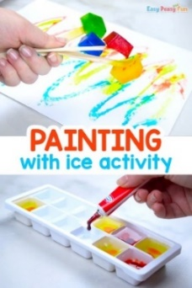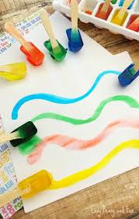
Or you could freeze some of your favourite toys…
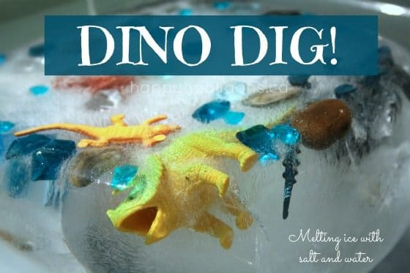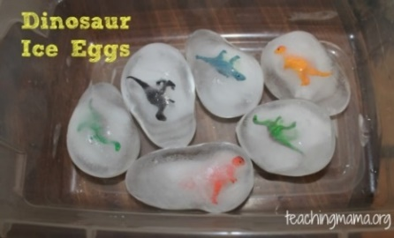
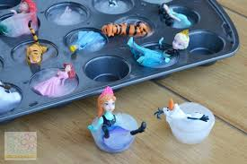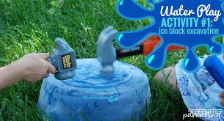
How can you free them from the ice?
What does it feel like?
What makes it melt?
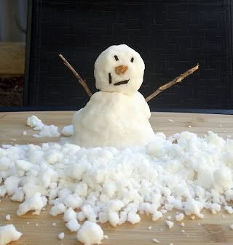
Want to bring the snow indoors?
Fake snow recipe
2 cups of cornflour and ¼ cup of oil
Or
4 cups of cornflour and ½ cup of oil
Mix well and have fun!

I’d love to see you make some snowy artwork too.
Here are some links to phonics games and one of our favourite stories from last term:
https://www.phonicsplay.co.uk/resources/phase/1/welcome-to-the-zoo
https://www.youtube.com/watch?v=UAdviuJ4H20

