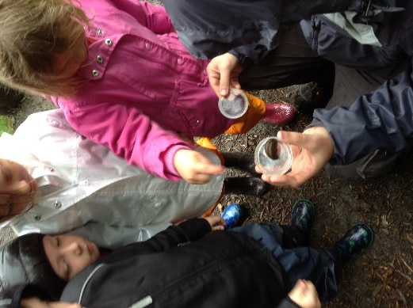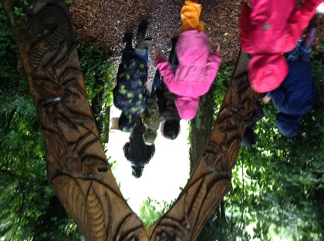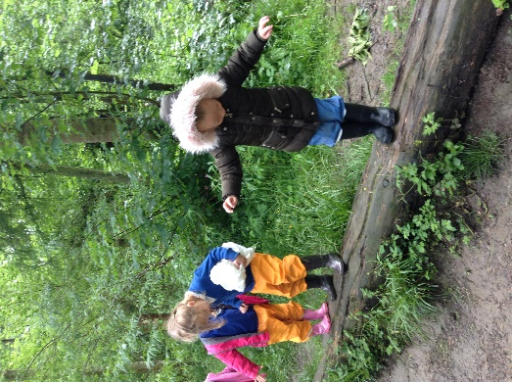

This week Reception children enjoyed a very wet and wonderful day at Guisbrough walkway. They searched for mini-beasts in their different habitats and were very excited to find lots of slugs, earwigs, spiders, snails and even a baby newt! The children also searched for caterpillars and learned about why they can be different colours.
Later, when the sun came out, the children enjoyed climbing and balancing on the equipment before they built their very own mini-beasts houses with things that they had foraged in the woods. They even brought some things they had collected back to school.

