Nursery Long Term Plan 2019-2020

Me and the Amazing world around me | Amazing world around me  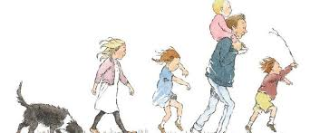 |  | Once upon a time… | Once upon a time… |  | The land before time.  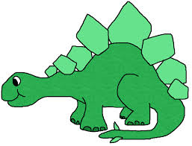 | Down under the Ocean  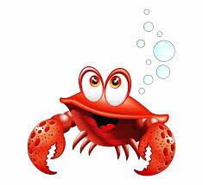
Possible Texts:  Marvelous me  You be you  Elmer  Head, shoulders, knees and toes  Enormous turnip  Scarecrows secret  Red leaf, Yellow leaf  We are going on a leaf hunt  Funny Bones  Run away Chapati | Possible Texts:  We are going on a bear hunt.  Brown Bear, brown bear.  I don’t care said the bear  Bear sees colours  This is bear  Twinkle Twinkle little star  Christmas story  Donkey’s First Christmas |  | Possible Text:  Winter poems  Winter is Here  5 little snowmen  Animals in Winter  Gingerbread man  Billy Goats Gruff | Possible Texts:  Three little Pigs  Little Red Riding Hood  It’s Spring  Mary had a little lamb  5 bunnies hopping on a hill  We’re going on an egg hunt |  | Possible Texts:  Dinosaur roar  Stomp, Chomp, big roars  Saturday night dinosaur stomp  Dinosaurs love underpants  How to grow a dinosaur | Possible Texts:  1,2,3,4,5 Once I caught a fish alive  Tiddler  Sharing a shell  Hello Ocean  Singing mermaid  Information texts – animals, ocean and seas ect.
Prime Areas of Learning
Personal, Social and  Emotional Development |  | Throughout Nursery children will learn:  - To speak with confidence to new adults and friends  - To share toys with others  - To play alongside others  - Classroom routines and rules  - To develop relationships with other people  - To make new friends  - To take turns  - How to deal with our emotions appropriately  - To develop confidence during carpet and circle times  - To express their feelings and interests  - To care for each other and animals  - To understand others needs and feelings  - • To deal with changes in a positive way
Physical Development |  | Throughout Nursery children will:  - Develop gross motor skills through outdoor play; running, climbing, balancing, building etc  - Develop fine motor skills such as; pencil grip, scissor control, manipulating small objects (threading, jigsaws, small construction)  - Learn self-help skills such as; general hygiene, toileting, washing hands, feeding themselves appropriately
Communication and  Language |  | Throughout Nursery children with learn:  - To speak with confidence during carpet / circle times  - To listen and respond appropriately with relevant comments,  - questions or actions  - How to greet and interact with friends and adults  - New vocabulary relating to different topics and events  - How to make their needs known  - To use appropriate story language to re-enact/re-tell simple and familiar stories
Specific Areas of Learning
Literacy |  | Throughout Nursery children will:  - Listen to a range of stories during carpet time – beginning with simple repetitive texts, nursery rhymes, listening to whole stories  - Know the difference between fact and fiction  - Begin to understand print carries meaning  - Experiment with mark making using different resources  - Learn to recognise print in the environment  - Enhance pencil control  - Begin to form letters, numerals and shapes  - Re-tell stories through puppets and role play  - Learn to recognise and begin to write own names
Phonics |  | Environmental sounds  Alliteration  Instrumental sounds  Body Percussion  Rhythm and Rhyme  Voice Sounds  Blending and Segmenting – Beginning to hear and say sounds in words |  |  | Set one sounds
Mathematics |  | Throughout Nursery children will be:  - Counting through songs, stories and in their play  - Recognising quantities of objects  - Recognising numerals in the environment  - Using some number names and language  - Showing awareness of numbers in the environment  - Exploring 2d shapes in the environment  - Showing awareness of time through class routines  - Comparing objects by size  - Reciting number rhymes  - Exploring different shapes, spaces and measures  - Counting to 10 (and beyond)  - Counting objects and saying how many there are in a set  - Using fingers and marks on paper to represent numbers  - Recognising, naming an ordering numerals to 10  - Counting objects, sounds or actions
Understanding the World |  | Throughout Nursery children will be:  - Talking about themselves, their interest, families and favourite  - things  - Sharing thoughts and experiences about families and how families  - can be similar or different to others  - Thinking about different people and how they help us  - Talking about those who are important to them and why  - Sharing experiences and feelings about different festivals and how  - they are celebrated  - Recognising signs of the seasons, talking about the changes in the  - weather and environment  - Comparing different animals and thinking about their similarities  - and differences  - Exploring different technologies in school
Expressive Arts and  Design |  | Throughout Nursery children will be:  - Using a range of media, tools and materials in their artwork  - Exploring different musical instruments and using them to make music  - Using their imagination for role play

